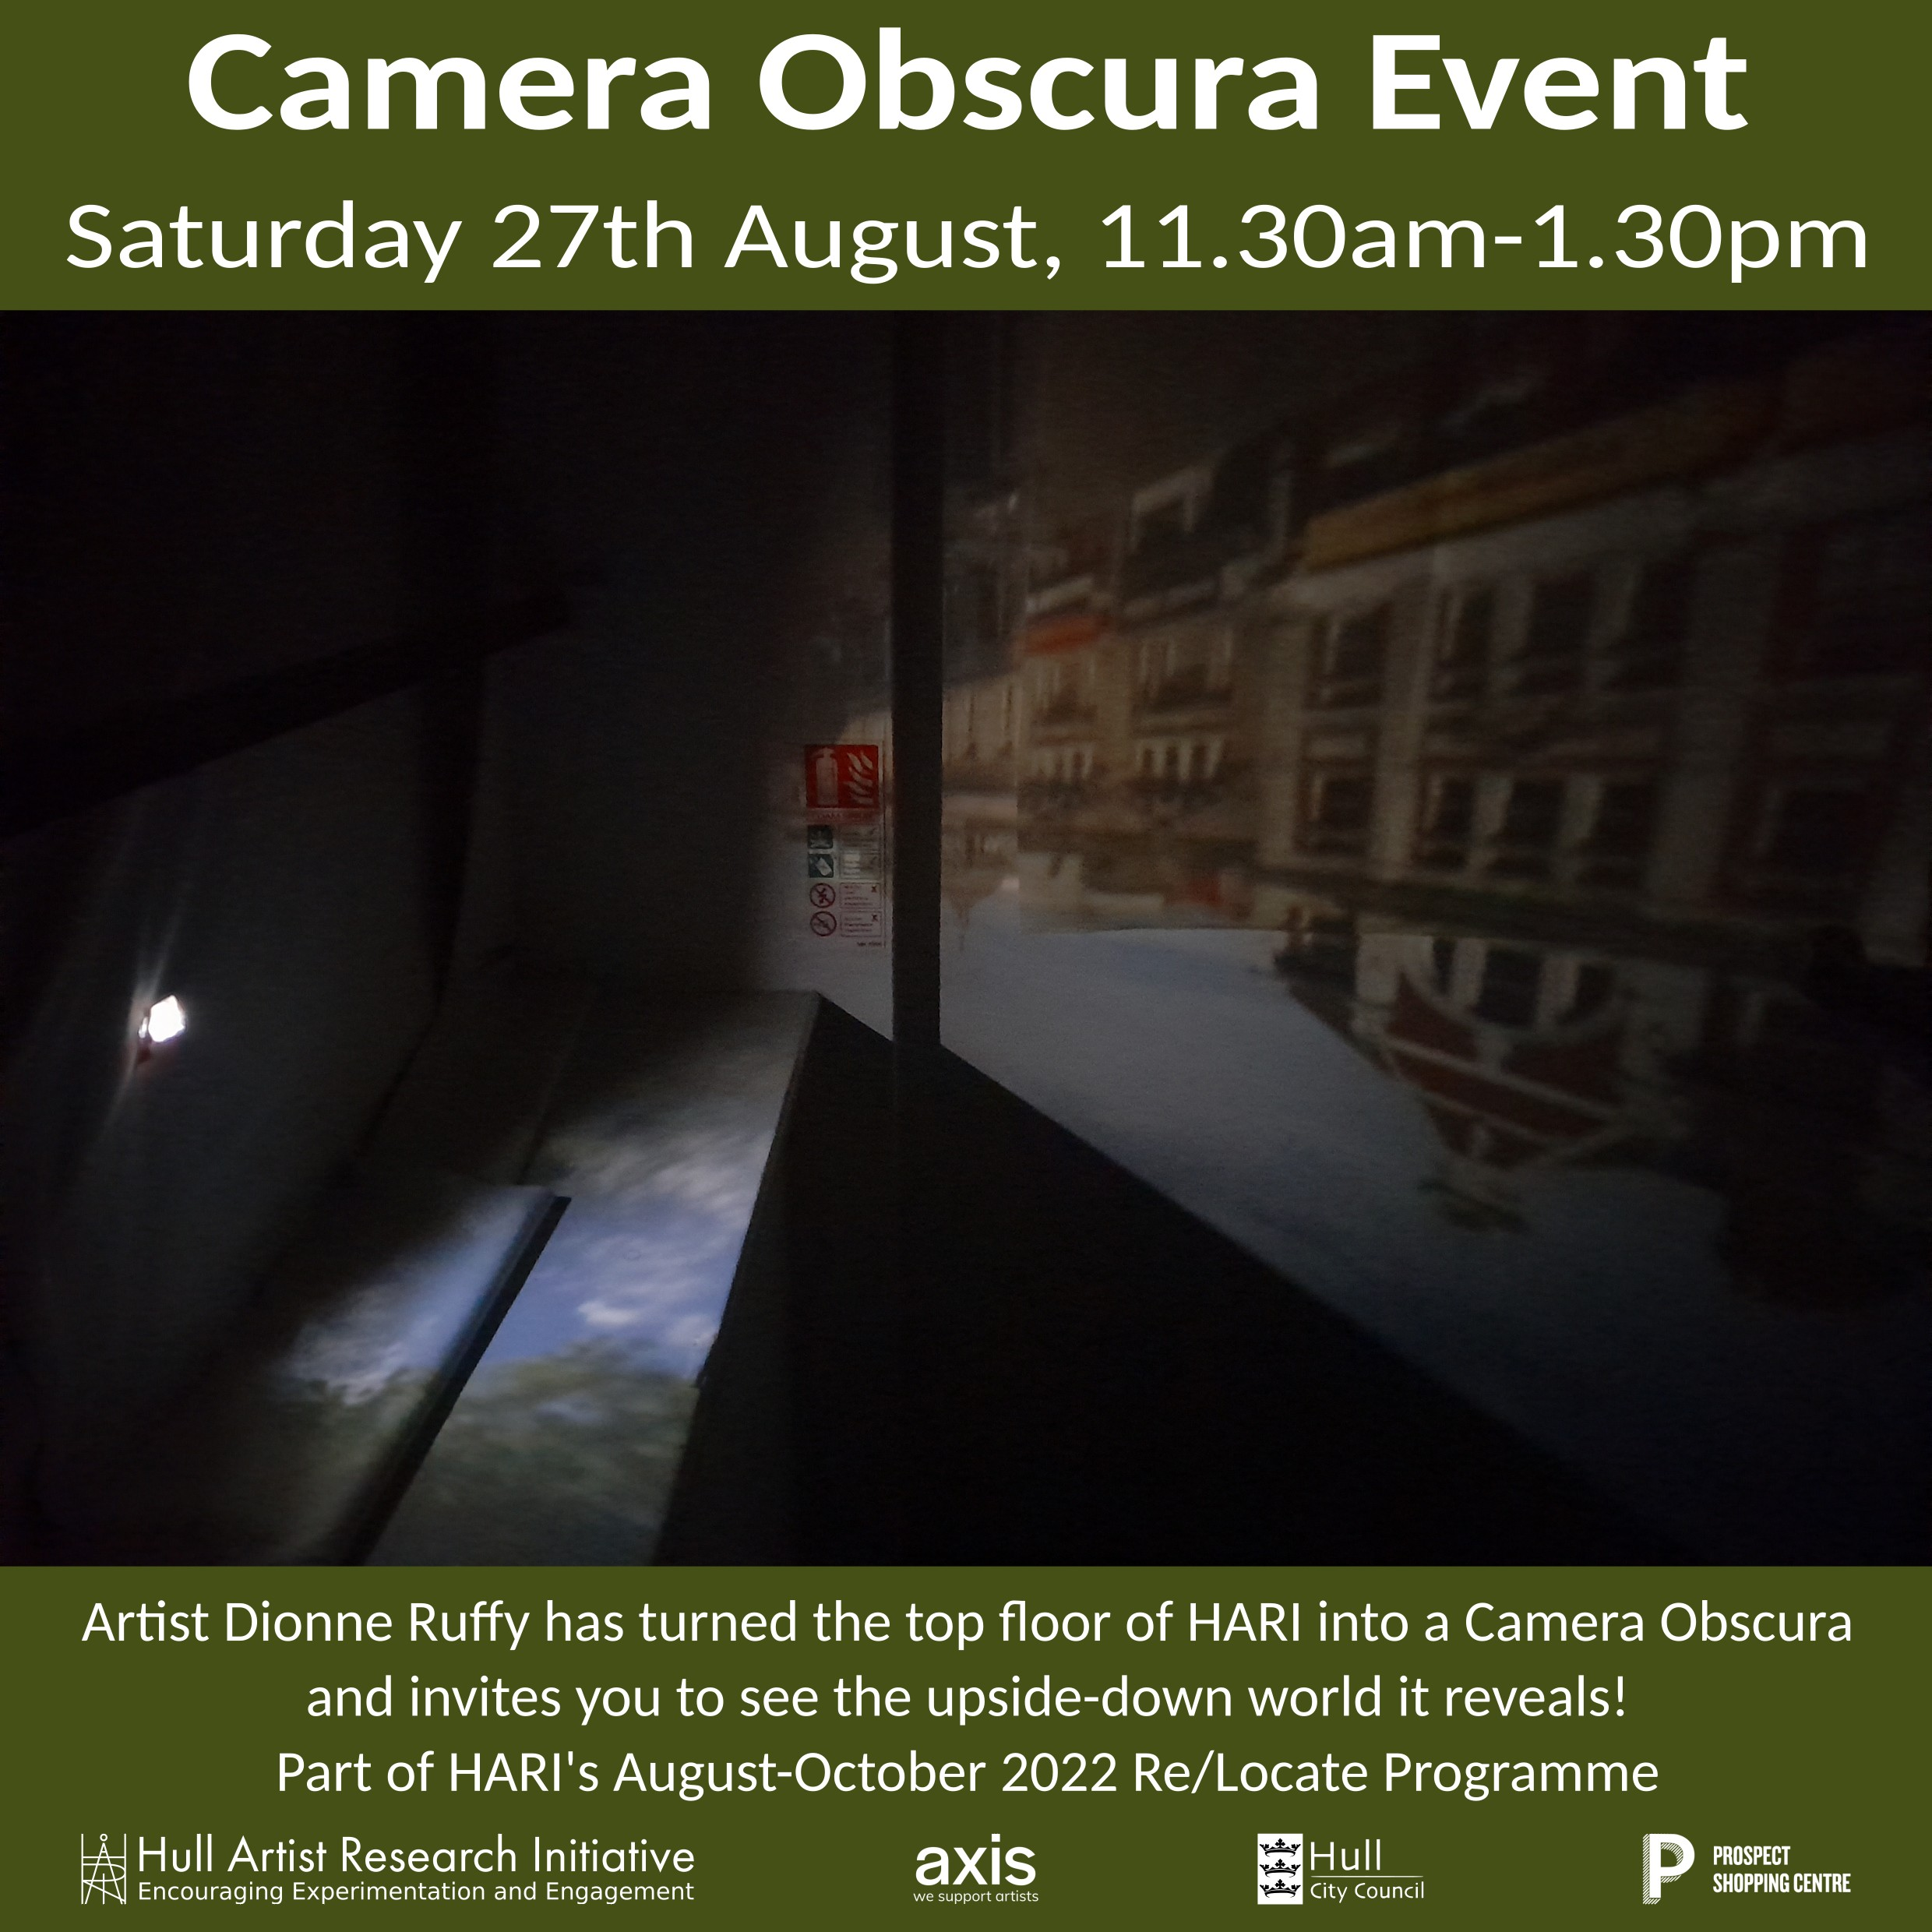

Small group viewings of the space with the artist,
who gives a talk on her processes and motivations at 1pm.

Instagram: @miss_i_dru_this

